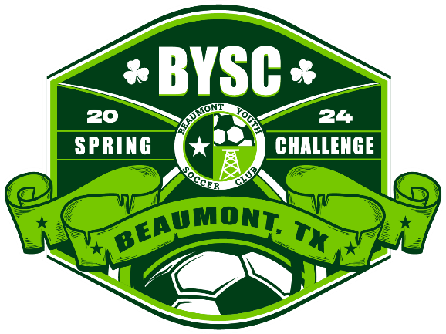
Rules of Play – 7v7 (U9-U10)
I. Game Format
A. 7v7–7 players max on the field for each team,6 field players plus a goalkeeper.
B. Minimum Players–a team must have 5players to start or continue a game.
C. Game length-40 minutes, in 2 20-minute halves with a 5-minute halftime.
D. Uniforms–Each team must wear distinctive uniforms with unique jersey numbers for each
player. Home teams should wear their lighter uniforms, away teams their darker uniforms. In case of a
uniform conflict, the home team should change. The referee has final say on whether uniforms conflict.
Goalkeepers must wear a jersey or pinnie that distinguishes them from their teammates and opponents.
Note: The ultimate goal is to play the game. If the uniforms conflict and the home team has no alternate
jerseys the away team should change. If neither team has alternate jerseys pinnies may be used. The
conflict must be resolved or both teams may be subject to a forfeit (0 points and -3 goal difference for
both teams)
E. Start of Game–The referee should use a coin toss to determine which side the teams start on and
which team kicks off.
F. Substitutions – Unlimited at any stoppage with referee permission.
G. Sideline Restarts – If the ball goes out of play across a sideline possession is granted to the
team which did not touch the ball last. A player from the possessing team returns the ball to the sideline
at the point it exited the field. The player may Restart the play with a throw-in using FIFA rules.
II. Concussion Initiative
BYSC will follow the guidelines that US Soccer has set out for the concussion initiative, with the two
components below:
A. Head Injuries - If a player is suspected to have a head injury the referee is instructed to stop play to
allow for treatment/evaluation as needed. If the player leaves the field of play for
additional evaluation, a substitution can be made in that moment. The player with the suspected head
injury may not return to the game unless a Health Care Professional (HCP) or Certified Athletic Trainer
(ATC) has cleared the player. Any coach or parent insisting on returning the player to the game without
approved clearance will result in the referee ending the game.
B. Heading - Deliberate heading is not allowed in 7v7 games (≤U11). If a player deliberately heads the
ball in a game, an indirect free kick should be awarded to the opposing team from the spot of the
offense. Unless the offense is within the penalty area, in which case the kick should be given at the
nearest place to the top of the penalty area. If the deliberate header occurs within the goal area, the
indirect free kick should be taken on the goal area line parallel to the goal line at the nearest point to
where the infringement occurred.
III. Build Out Lines and Offside
A. Definition–Build Out Lines will be placed equidistant between the penalty area and halfway
line. The build out line has been adopted by US Soccer to promote playing the ball out of the
back in an unpressured setting.
B. Goalkeeper Possession–When the goalkeeper has the ball in their hands during play from
the opponent, the opposing team must move behind the build out line until the ball is put in play. Once
the opposing team is behind the build out line, the goalkeeper can pass, throw, or roll the ball into play.
After the ball is put into play (by leaving the penalty area) by the goalkeeper, the opposing team can
cross the build out line and play resumes as normal. If a fast restart is initiated by the goalkeeper (time
for opponent retreat is not given), play proceeds as normal. Note: Punts and drop kicks are not allowed.
If the goalkeeper attempts to punt or drop kick the ball they will be asked to restart the play with the
ball in their possession.
C. Defensive Restarts–Goal kicks and other defensive restarts which occur behind the penalty line will
also require the opposing team to move behind the build out line until the ball is put into play.
D. Misconduct/Delay of Restart-Referees should be mindful of any intentional delays being caused by
opponents not retreating in a timely manner or encroaching over the build out line prior to the ball
being put into play. Referees can manage the situation with misconduct if deemed appropriate.
Referees should be flexible when enforcing the 6 second rule and counting the time of possession
should only begin when all opponents have moved behind the build out line.
E. Offside-The midline will be used to denote where offside offenses can be called. Players can be
penalized for an offside offense between the halfway line and the build out line.
IV. Coach/Spectator/Trainer Instruction
Coaches/Substitutes/Substituted player/Spectators/Trainers are not allowed on the field of the play for
the purpose of instruction or otherwise (the only exception is dealing with an injured player after
receiving permission from the referee). Constructive comments can be made from their technical area
without reprimand. Spectators should not instruct from the viewing area. The coach/trainer or team
supervisor can be approached to control their spectators. Actions contrary to the “good of the game”
may result in removal. In the event that a “sporting environment cannot be restored or attained”, either
or both teams may result in forfeit. Actions that are deemed violent, threatening, obscene, or publicly
indecent will be reviewed by civil authorities present or called as necessary.
V. All Other Rules Conform to FIFA Laws of the Game Updated 8/202

